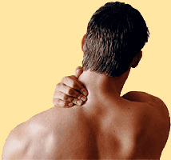
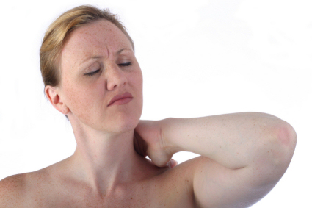
Have you been
diagnosed with FIBROMYALGIA? & Have you experienced at least
1 TRAUMATIC EVENT in your lifetime?
You may qualify for a valuable research study. It will only take about 20-30 minutes of your time. You will receive a $5 gift card to HEB if you decide to participate and complete all required forms.

- Ask Dr. Connolly or his staff members if you would like to participate.
- If you have additional questions, you can contact
Kristin Sramek
cell: 210-430-1111 / kristinsramek@yahoo.com

